
The Deadly Corona Virus
As of Tuesday, more than 4,500 cases have been confirmed in China, its country of origin, of which 106 have been fatal. Several cases have been detected in Asian countries, as well as a few in Australia, France and the United States.
Statistically speaking
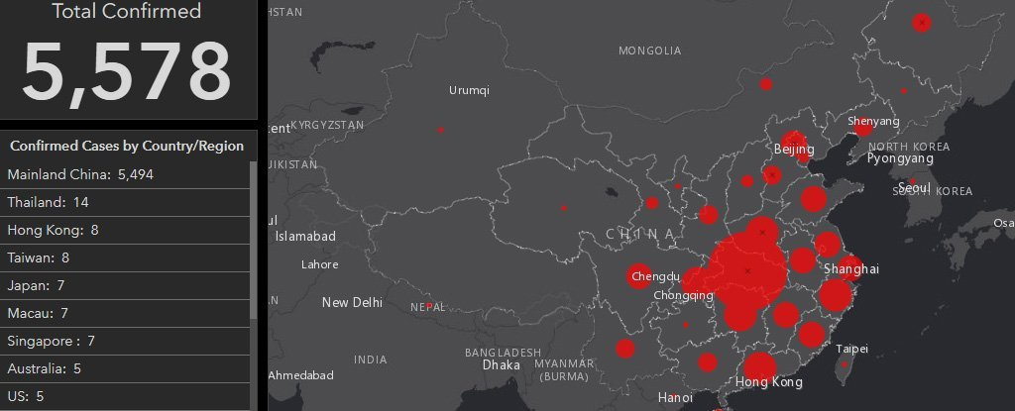
So far, no-one outside China has died, but both Germany and Japan on Tuesday confirmed cases of human-to-human transmission of the disease.
2019-nCoV, as it has been named, is part of the coronavirus virus family, the source of two previous fatal epidemics.
Origins
Researchers think the new virus probably came from bats, as the SARS virus did, with which it shares 80 percent of its genetic makeup.
But we still don't know which animal passed it on to humans. Last week a Chinese team suggested it could be a snake, but that was immediately challenged by other experts, who think a mammal is the more likely culprit.
Identifying which animal it was could help fight the outbreak.

What needs to be done
Health authorities and scientists say the same precautions against other viral illnesses can be used: wash your hands frequently, cover up your coughs, try not to touch your face.
And anyone who does come down with the virus should be placed in isolation.

