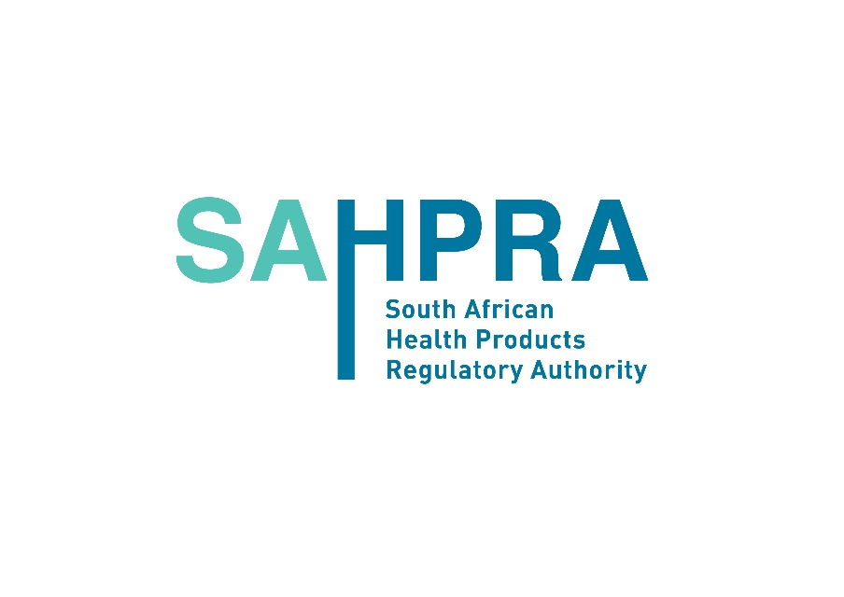
SAHPRA- Update for Interaction with SAHPRA
The new coronavirus (COVID-19) is having an impact on business locally, regionally and globally. SAHPRA is by no means an exception.
In this vein, SAHPRA would like to advise its stakeholders of the following protocols:
- If at all possible, try and avoid visiting the SAHPRA offices because it creates a risk of spreading the COVID-19 virus.
- If you are ill or were ill in the past week, or if you have travelled to any of the affected countries in the recent past, please do NOT visit the SAHPRA offices. Use digital means to communicate with SAHPRA.
- If it is absolutely necessary that you have to visit the SAHPRA offices, please ensure that you make an appointment.
- Please note that all permits, certificates, licences, recommendations, resolutions and letters will no longer be collected from SAHPRA offices, including SAHPRA reception in building 38. These will be e-mailed to applicants. The original documents will be collected at a date to be communicated by SAHPRA to industry.
- Our offices will have hand sanitiser. Please ensure that you use this before any interaction commences at our offices.
- Some of our staff members will wear masks and/or gloves while interacting with members of the public or applicants, particularly those in our reception area.
- Please observe all signs and directives by SAHPRA staff members, especially those involving social distancing.
At this stage, SAHPRA is still fully functional and we aim to maintain this status – and you can help!
All official travel for SAHPRA staff members has been suspended until further notice.
Meetings with external stakeholders will now be held on virtual platforms.

