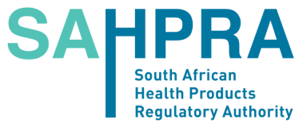 Radiation Control
Private Bag X62 Enquiries: Admin
RN621
BELLVILLE : 021-957 7472 / 021-015 5511
7535 radionuclides@sahpra.org.za

APPLICATION TO RELEASE EQUIPMENT CONTAINING
SEALED RADIOACTIVE SOURCES FROM STORAGE AT NECSA NLM

Complete this form by typing or writing in legible block letters in black ink
and email it to radionuclides@sahpra.org.za.

1. SURNAME OF APPLICANT
2. FIRST NAMES
3. IDENTITY NUMBER
4. COMPANY NAME:
4. AUTHORITY NUMBER
5. CONTACT DETAILS
Phone: | Cellphone:
Fax no: | Email:

6. ADDRESS
Postal address (to be used for correspondence): | Premises address (where radionuclides are to be installed/use/stored):
Postal code:
Business phone: | Suburb:
Fax no: | City:

7. Details of SOURCE(S) to be released: List each source individually. Add a page if needed.

8. PAYMENT DUE TO NECSA NLM FOR STORAGE/HANDLING FEE
Amount due:

9. DECLARATION

I declare that the information given above is true and correct.

SIGNATURE OF APPLICANT DATE

APPROVAL TO RELEASE EQUIPMENT FROM STORAGE - FOR OFFICIAL USE ONLY
DATE OF APPROVAL
APPROVED BY:
SIGNATURE:
NAME:
DESIGNATION:
ARRANGED WITH (Name) at NLM (NECSA)
DATE:
Proof of payment received confirmed

Download the current Radionuclides forms from www.sahpra.org.za (Health Products tab).

